**PROGRAMME: BCA (Bachelor of Computer Applications) - General**

**SEMESTER – V**

**Teaching-Learning & Evaluation Plan**

**Course Information:**

Course Code: **23BCA3C01L**  Course Title: **DBMS LAB**

Credits Units: **01** Contact Hours: **30** L-T-P: **0-0-2**

CA Weightage - **1-0-0**  Pass Marks (CA) – **40** Special Examination Fees: **NA**

Course Facilitator (s): **Dr.Santhalakshmi.M, Dr. Clara shanthi, Dr.Suma, Dr.Pratima, Dr.Yashaswini**

**.**

**Programme Outcomes (POs)**

| At the end of the programme, students will be able to | |
| --- | --- |
| PO 1 | **Computational Knowledge:** Understand and apply mathematical foundation, computing and domain knowledge for the conceptualization of computing models from defined problems. |
| PO 2 | **Problem Analysis:** Ability to identify, critically analyze and formulate complex computing problems using fundamentals of computer science and application domains. |
| PO 3 | **Design / Development of Solutions:** Ability to transform complex business scenarios and contemporary issues into problems, investigate, understand and propose integrated solutions using emerging technologies. |
| PO 4 | **Conduct Investigations of Complex Computing Problems:** Ability to devise and conduct experiments, interpret data and provide well informed conclusions. |
| PO 5 | **Modern Tool Usage:** Ability to select modern computing tools, skills and techniques necessary for innovative software solutions. |
| PO 6 | **Professional Ethics:** Ability to apply and commit professional ethics and cyber regulations in a global economic environment. |
| PO 7 | **Life-long Learning:** Recognize the need for and develop the ability to engage in continuous learning as a Computing professional. |
| PO 8 | **Project Management:** Ability to understand management and computing principles with computing knowledge to manage projects in multidisciplinary environments. |
| PO 9 | **Communication Efficacy:** Communicate effectively with the computing community as well as society by being able to comprehend effective documentations and presentations. |
| PO 10 | **Societal & Environmental Concern:** Ability to recognize economic, environmental, social, health, legal, ethical issues involved in the use of computer technology and other consequential responsibilities relevant to professional practice. |
| PO11 | **Individual & Team Work:** Ability to work as a member or leader in diverse teams in multidisciplinary environment. |
| PO12 | **Innovation and Entrepreneurship**: Identify opportunities, entrepreneurship vision and use of innovative ideas to create value and wealth for the betterment of the individual and society. |

**Programme Specific Outcomes (PSOs)**

| PSO 01 | Pertain current knowledge and adapting to emerging applications of Mathematics, Science fundamentals in the field of Computer science and its applications. |
| --- | --- |
| PSO 02 | Exhibit proficiency in identifying, formulating and analyzing complex problems in the computer environment. |
| PSO 03 | Ability to create, select and apply appropriate modern techniques for solving complex issues. |
| PSO 04 | Explore technical knowledge in diverse areas of Computer Applications and experience a conductive environment in nurturing skills for successful career and higher studies. |

**Course Outcomes:**

At the end of the course, students will be able to

| Sl. No. | Course Outcome | Description | Bloom’s Taxonomy Level |
| --- | --- | --- | --- |
| 1. | CO1 | Understanding the entities, attributes and relationships, mapping constraints and concept of normalization. | L3 |
| 2. | CO2 | * Accessing the data and retrieve using SQL using constraints. | L3 |
| 3. | CO3 | Analyzing the data from database using SQL operations | L4 |
| 4. | CO4 | Analysing data from database using Aggregate and built –in functions | L4 |
| 5. | CO5 | Understand and Analyze Database using DML operations, key constraints ,views ,joins and using privileges. | L4 |

**CO-PO/PSO Mapping: (**3-Strong Correlation 2- Medium Correlation 1- Low Correlation)

| **Course Outcomes** | **Blooms Taxonomy Level** | **Programme Outcomes (PO)** | | | | | | | | | | | | **Programme Specific Outcomes (PSO)** | | | |
| --- | --- | --- | --- | --- | --- | --- | --- | --- | --- | --- | --- | --- | --- | --- | --- | --- | --- |
|  |  | PO  01 | PO  02 | PO  03 | PO  04 | PO  05 | PO  06 | PO  07 | PO  08 | PO  09 | PO  10 | PO  11 | PO  12 | PSO  1 | PSO  2 | PSO  3 | PSO  4 |
| CO1 | L3 | 2 | - | - | - | 2 | - | 1 | - | - | - | - | - | 2 | - | - | 2 |
| CO2 | L3 | 3 | - | - | - | 2 | - | - | - | - | - | - | - | 2 | - | - | 2 |
| CO3 | L4 | 3 | 2 | - | - | 2 | - | 2 | - | - | - | - | - | 2 | - | - | 2 |
| CO4 | L4 | 3 | 3 | - | - | 3 | - | - | - | - | - | - | - | 2 | 2 | 2 | 2 |
| CO5 | L4 | 3 | 3 | 3 | - | - | - | - | - | - | - | - | - | 2 | 2 | 2 | 2 |
|  | Average | 2.8 | 2.6 | 3 | - | 2.2 | - | 1.5 | - | - | - | - | - | 2 | 2 | 2 | 2 |

**Syllabus**

| **Experiment No** | **Name of the Experiment** | **Marks** | **CO** |
| --- | --- | --- | --- |
| Experiment 1 | Suppose you are given the following requirements for a simple database for the National Hockey League (NHL):   * NHL has many teams, * each team has a name, a city, a coach, a captain, and a set of players, * each player belongs to only one team, * each player has a name, a position (such as left wing or goalie), a skill level, and * a set of injury records, * a team captain is also a player, * a game is played between two teams (referred to as host_team and guest_team) * has a date (such as May 11th, 1999) and a score (such as 4 to 2). * Construct a clean and concise ER diagram for the NHL database   Suppose you are given the following requirements for a simple database for the National Hockey League (NHL):  (referred to as host_team and guest_team) and has a date (such as May 11th, 1999) and a score (such as 4 to 2). Construct a clean and concise ERdiagram for the NHL database | 25 | CO1 |
| Experiment 2 | A university registrar’s office maintains data about the following entities:   1. courses, including number, title, credits, syllabus, and prerequisites; 2. course offerings, including course number, year, semester, section number, instructor(s), timings, and classroom; 3. students, including student- id, name, and program;   instructors, including Identification number, name, department, and title. Further, the enrollment of students in courses and grades awarded to students in each course they are enrolled for must be appropriately modeled. Construct an E- R diagram for the registrar’s office. Document all assumptions that you make about the mapping constraints, implement normalization.., | 25 | CO1 |
| Experiment 3 | 1. Write a query to display the empno, ename, job, hiredate, provide alias for each column, display employees who is working as PRESIDENT or   ANALYST, and employees belonging to deptno 10 or 20,and ename should not starts with S.   1. WAQ to display ename, salary, comm, calculate total salary and annual salary of all employees whose salary ranges from 1000 and 2500, and   employees are belong to department 10 or 30. And who is working as SALESMAN.   1. Write a query to display ENAME, SAL, DEPTNO, display only employees who is not working under any manager. 2. Write a query to display ENAME, SAL, HIRDATE display Details of employees who have been with the company for more than thirty years, who is not drawing salary from 1500 to 3000.   WAQ to display ename, deptno, salary, comm and find increment of salary by 10%, and increment of commission by 5% for all employees and sort salary and department number | 25 | CO2,CO3 |
| Experiment 4 | 1. WAQ to display the details of all employees whose name is Smith. But you are not sure in which case enames are stored. Which statement will list all the employees whose ename is Smith? 2. WAQ to display ename, mgr, sal and comm where employees are not working under any manager as a value as NO 3. MANAGER and comm as NO COMMISSION where employees are not taking any commission from the deptno 10 0r 20. 4. WAQ to display the sum of the salary of all employees according to department and job whose sum of the salary more than 5000, sort the deptno column in ascending order. 5. WAQ to display ename and commission,if commission is null then replace with salary and if salary is also null then replace with 1000. 6. Write a query to display maximum average salary of the employees according to deptno. 7. Write a query to hike the salary of the employees below jobs using CASE Job is CLERK hike by 15% If job is SALESMAN hike by 10% Or if job is ANALYST by 12%   Write a query to display the location from the department table as short Eg: NewYork as NY, Dallas DS, Chicago CG, and BOSTON as BT. | 25 | CO2,CO3 |
| Experiment 5 | 1. Write a query to find the sum of salary by grouping according to job and deptno having cross tabulation. 2. Write a query find the sum of the salary for job and find the grand total. 3. Management wants to know the maximum salary of all the employees for each deptno, and display only if maximum salary greater than 2800 ,sort   maximum salary in descending order.   1. WAQ to display employee name sal, comm, department name, location and calculate total salary, annual salary for the department name RESEARCH or OPERATIONS, sort annual salary in ascending order iii. Write a query to display the list of employees working under which manager. 2. Write a query to display ename and salary in dollar and prefix left white space of salary by special character by * and employees belongs to deptno 30 and 40, who is working as salesman and clerk. 3. Write a query to find the sum of the salary for each department name and for each location, display only sum of the salary should not be equal to   10000. | 25 | CO2,CO3 |
| Experiment 6 | 1. WAQ to display ename , hiredate, sal and job where salary should be similar to CLARK‟s salary. 2. WAQ to display which employee is getting minimum salary from the deptno 30. 3. WAQT to display employee name, job and there department name whose job should be similar to JONES job and deptno similar to empno 7934. 4. WAQ to display empno,ename,job and salary where the salary should be less than CLERK‟s salary.and job job should   not be equal to SALESMAN. | 25 | CO3,CO4 |
| Experiment 7 | 1. WAQT Display empno, ename, deptno and location of employee KING and salary between 1000$ to 2000$. 2. WAQ to find average salary for each job,deptno and loc and display only details if average salary greater than 5000$. (Use natural join) 3. Write a query to display all matching and non-matching details from emp . 4. Write a query to display all matching and non-matching records from emp as left table and dept table as right.   Write a query to display all matching and non matching records from dept as right table. | 25 | CO3,CO4 |
| Experiment 8 | 1. Write a query to insert the three records to emp table at run time. 2. Write a Query to update the salary of the employee by 15%, where the employee should work under the deptno of SMITH 3. Write a query to delete the record from emp table where the employee should be working as similar to JONES. 4. Write a query to delete deptno 10 from dept table. Mention the error if there is any error exists.   Write a query to insert single record to emp table | 25 | CO4,CO5 |
| Experiment 9 | Create the table called product with attributes pno, pname, pprice, qty and total add the constraint not null for the required columns and add check  constraint to price >0   1. Add the constraint primary key to pno by modifying the table. 2. Insert five records to product table at run time. 3. Then add new column special_offer 4. Delete first three records.   Truncate the table product | 25 | CO4,CO5 |
| Experiment 10 | Create a view empvu20 which has all employees details work for the deptno 20.   1. Write a query to create view on emp and dept table which has details like ename, deptno, sal, dname and loc for deptno 10, and salary should be   between 1000 to 2000 and who are not drawing commission.   1. Write a query to create view as EMPDETAILS from the tables EMP, DEPT and SALGRADE which contains empno, ename, job, sal, deptno,   name,loc and grade, where employees working as ANALYST and are not belongs to deptno 10 and 20.   1. Modify the EMPDETAILS view by using required clause. Add an alias for each column name 2. Create a complex view dept_sum_view, store dname, minimum salary, maximum salary and average salary department wise. | 25 | CO4,CO5 |
| Experiment 11 | Create table job_hostory By Copying the structure data from emp table.  Insert three records to emp table.   1. WAQ to display unique records from both table emp and job_history 2. WAQ to Display the employees work for the company from since from beginning to till date from both the table emp and job_history   WAQ to display employees joined recently leaving who has joined since beginning. | 25 | CO4,CO5 |
| Experiment 12 | Create A new user called JAINBCAIIISEM with the password jain.  Change the password jain as BCA for the user JAINBCAIIISEM.   1. Provide the permission to the user JAINBCAIIISEM for create session, creating table, view. 2. Take the permission create view from the user JAINBCAIIISEM 3. Take back all the DML permission from the user JAINBCAIIISEM 4. Create the role called HR and provide the privileges create table, create view to HR. 5. Provide the HR role to ram and shyam.   Remove the created role HR and remove ram and shyam.. | 25 | CO4,CO5 |

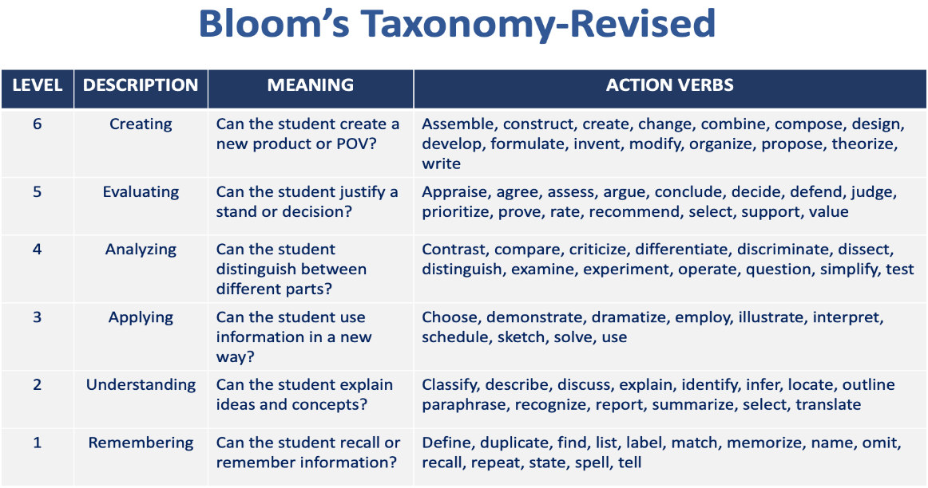

**Signature of the Faculty Signature of the HoD**